Lesson 10

Common Editing
As part of the Visual Basic Environment there are three principle areas that can be used to change the appearance of the finished program.
- The property window.
- The view object window
- And the program code (or instructions)
All three of areas can be used in different ways to make the program change.
For this lesson consider the following simple form.
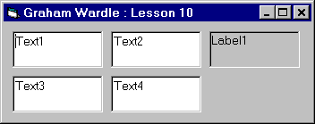
The form consists of four Text Boxes and one Label. The names of the Text boxes are Text1, Text2, Text3, and Text4. The name of the Label is Label1. Each of the five objects was added to the form by using the default settings. The default values of the properties were then changed in order that they appeared on the form as above. The following properties were changed.
- Top: The position of the top edge of the Text Boxes and the Label.
- Left: The position of the left edge of the Text Boxes and the Label.
- BorderStyle: The Style of border for the Label.

Using the view object window
The object view window can be selected by pressing the second Icon in the Project window Toolbar or by Menu View, Object.
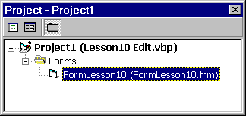
The object view can be used to select objects you may wish to change and then the property that is to be changed is the edited in the property window. There are four of properties that may be altered solely by the mouse within the object-viewing window. They are all position and size properties. The mouse may be used to drag the object once selected to a new position. With the mouse it is also possible to select more than one object. Multiple object selection may be done by the use of the shift key while clicking the mouse. When more than one object is selected, the property window will change how the properties appear. For the properties that are identical in value the property value will be displayed. For properties that differ the property value is blank. To show this use the mouse and shift key to select more than one object and look at the property values. As an example, for text boxes Text1 and Text2 the common value of 120 was set for the Top property whereas the Left property is different and is blank. If a value is written into the property of left then both objects will have the left set to that value. This can be useful if you wish to align objects or to set some property to all the same value. There are a few properties that may not be set in this way; one of such is the name.
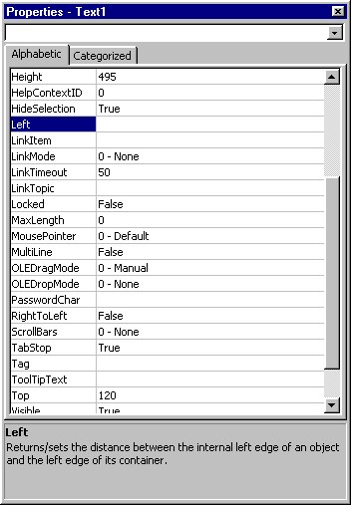
In addition to being able to change common properties, objects that have been selected. It is also possible to change the position of the objects together by moving one of the selected objects.

Using the Property Window to change an objects behaviour
The property window is a list of the properties of the object that is selected. There are four principle areas in the window. They are as follows.
- The Object List Box, which may be used to pick the object from those in the form.
- The Alphabetic and Category Tabs, which may be used to select how the properties are listed.
- The property name column displayed.
- The property value column, which is where the value is displayed or where the property may be edited. For some properties a list box is provided. For others a text box is provided. Many of the properties are not part of the required learning for this level of the course. There approximately 10% of the properties that will be used by 90% of the programs, 90% of the time.
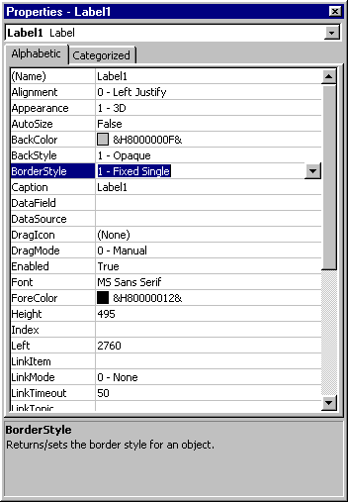
The properties that you need to learn about for this course are as follows.
- Name
- Caption or Text
- Left, Top, Width, and Height.
- Fore Color and Back Color
- Font name, Font size, Font Bold, Font Italic and a few more font properties.
- Enabled, Visible, Window style and Border style.
- Interval
Not all properties apply to any one object as an illustration a text box has a text property, a Label has similar property but it is a Caption, a timer has neither of these properties. Some properties may read only and cannot be edited. Such properties are the ClientHeight and ClientWidth.

Using the code to change appearance
Code can be used in many ways to alter the appearance of the program. All code in Visual Basic has to be in sub procedures. There are three different types of sub procedures with Visual Basic and they are as follows.
- General procedures within a code module.
- General procedures within a form.
- Event procedures within a form.
All three types of procedure are defined in the same manner the only difference is how they are interpreted by the language of Visual Basic.

General procedures in modules
A General procedure within a code module is often used for special functions that are required by a program. Later in this course you will need to know how to write such functions and how to use them. There is one procedure that you need to be aware of is one called Main. This Main procedure can be added to a code module to be used as the optional starting place of the program. This procedure is how Basic Programs traditionally started and has been carried over into Visual Basic. It is no longer a requirement for the program to start in such a procedure. If the program does not start in the main procedure then it should start in one of the forms of the project. For the present we have only looked at single form programs, but later with multiple form projects the default start up form will be the first form, which is Form1. If the first form is deleted from the project you will then need to set the start up form to a new form or set the procedure Main as the starting place of the program.

General procedures in forms
A general procedure that is in the code of a form is a piece of code that has no association with an object. In order for a procedure to be linked to an object its name must contain the name of the object and the name of the event. If you write a procedure with a name that is not one of your program objects the program will consider that a general procedure. Later in this course we will look at being able to write general procedures, but for now we look at the principle of how this is done. The name of a general procedure may be anything, with the following two provisos. The procedure name cannot be a keyword nor an object event procedure name. An example of general procedures will be given in the solutions for project 5.

Event procedures in forms
An event procedure is a sub procedure that will be called when a windows event occurs for an object within the program. For the example program there are five objects on the form. The example code below is five sub procedures that are called if there is a click message for the objects. If the Label1 is clicked then the Label1_Click sub procedure is acted out. This procedure has a single action, which is to change the caption property of Label1. The caption of the label changes what text appears on the label. The click events for the text box objects similarly change the Text property of the text boxes. It should be noted that if there were not an object by that name, the procedure would not be considered as being an event procedure.
Private Sub Label1_Click()
Label1.Caption = Val(Text1.Text) + Val(Text2.Text) + Val(Text3.Text) + Val(Text4.Text)
End Sub
Private Sub Text1_Click()
Text1.Text = Val(Text4.Text) + 1
End Sub
Private Sub Text2_Click()
Text2.Text = Val(Text1.Text) + 1
End Sub
Private Sub Text3_Click()
Text3.Text = Val(Text2.Text) + 1
End Sub
Private Sub Text4_Click()
Text4.Text = Val(Text3.Text) + 1
End Sub

Changing the Visual Basic Environment
How the editing environment appears within Visual Basic can be changed to meet you requirements or personal choice. The early versions of Visual Basic had only a limited number of things that could be changed. A window similar to the property window called the environment window could change those few things. Since Visual Basic 5 these have been added to and are to be found on an options window. The menu Tools Options can show the Options window.
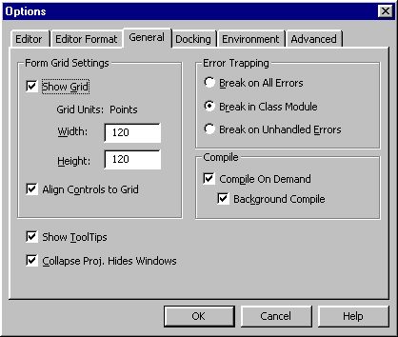
There are six tabs that can be used to select which parameters are visible. Once the various environment parameters are shown that may be changed to suit the requirements of the programmer. One set of the parameters that often changed is the Alignment grid settings. These can be found on the General Tab.
There are two environmental settings that I personally find useful to change from the default. The first change is the Auto Syntax Check; this disables a message appearing every time I leave a line with an error. If the line is in error will be set to a colour set by Editor Format (usually red), but you may continue typing on the next line or move to a line to copy text without having to interrupt by pressing a message box. The second change is to Require Variable Declaration, this then adds Option Explicit into the code so that if a piece of code has an undeclared variable then the program will stop on the instruction with that mistake in it. An example of that may be that the variable is declared but when used the variable is misspelt. If option explicit is not used the misspelt variable would be seen as a new variable requirement for which a default type would be variant with a default value of Empty would be assigned.

